**Feasibility Report**

**Health Fitness**

**Problem Statement:**

For many years people have been ignorant to taking care of themselves. Women were still sensitive to fitness issues but men considered themselves more rugged and ignored any advice to take care. But today men are equally conscious of their health and fitness. People today pay visits to gym and dieticians on a regular basis these days. Customers are interested in going to gym and workout but they rarely spend time on validating the quality of the products and the services. In India, People are worn out by the traffic, the heavy workload, late nights at the office, unpredictable weather conditions. The customers are also unaware of the fitness standards and hence due to all these complications people fail to identify the best fitness services which are offered near to them.

Key Problems:

* Lack of awareness
* Work Stress
* Huge Traffic(In Cities like Bangalore, Chennai, Mumbai, Delhi, etc.., )

**Project Business Requirement:**

The growing motivation for healthy and better living, coupled with time constraints of consumers will give rise to a number of instant solutions and remedies that can be bought off-the-shelf and bundled with health and beauty offerings.

To overcome the problem stated above it provides us a scope to create an application that would facilitate users to find nearby best Health Fitness Centre which listed according to the category of the services, ratings etc..,. A mobile application is best suited to meet all the requirements of the stated problem. The feedback collected from the users facilitates the future users to select the best Fitness Centers.

**Market Considerations:**

The population of India is 1.2 billion. That shows there is a huge market to provide fitness products and services. India has the world’s largest youth population according to UN report. According to the report India has 365 million people in the age group of 10-24. This is a big positive for fitness industry as youth forms the primary target group.

Multiple reports have pointed out that India has one of the highest number of people in the working age group. The average age of the country is expected to be around 29 by 2020, younger than China and US. The proportion of working population is expected to grow from 58% in 2001 to 64% in 2020 according to economic survey 2014.

Big opportunity lies in this industry for structured and organized players. Currently only 5% of the market is covered by organized players. As the services go up and customers become aware of it the number is bound to increase.

The whole Health and Fitness Industry combined together forms a huge market. In India is approximated to be around Rs680bn-Rs720bn. The Industry includes providing products and services. Services form 40% of the market. It is expected to grow at 15-17%.

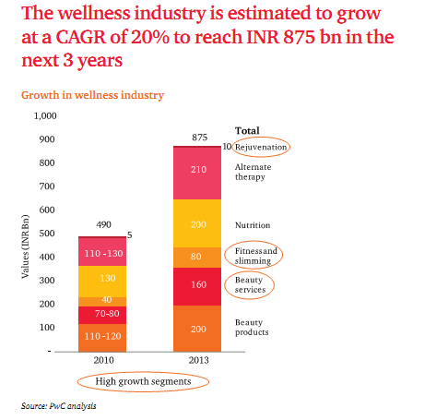

**CAGR: Compound Annual Growth Rate.**

***Source: FICCI-PwC Knowledge publication on the wellness industry in India “WELLNESS: Riding the growth wave”***

**Comparison of Existing System Vs Proposing System:**

|  |  |
| --- | --- |
| **Existing System** | **Proposing System** |
| Customer must visit to the Fitness centers and check for the facilities and courses being provided by them. | Customers can check the facilities and courses being offered in their mobile irrespective of where they are. |
| Most of the times customer blindly believe in the courses offered by the Fitness Centers. | Customers can check the reviews before joining to any of the courses. |
| Takes more time to figure out to choose the proper Fitness course and center. | All the required information will be present on the user’s screen so no worries about time. |

**Case Studies:**



***Source: FICCI-PwC Knowledge publication on the wellness industry in India “WELLNESS: Riding the growth wave”***

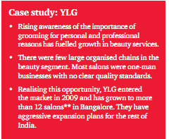

***Source: FICCI-PwC Knowledge publication on the wellness industry in India “WELLNESS: Riding the growth wave”***

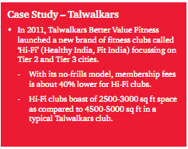

***Source: FICCI-PwC Knowledge publication on the wellness industry in India “WELLNESS: Riding the growth wave”***

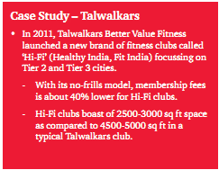

***Source: FICCI-PwC Knowledge publication on the wellness industry in India “WELLNESS: Riding the growth wave”***

**Marketing Plans:**

The young generation will continue to be conscious of personal appearance, pushing the demand for beauty services, fitness and slimming and rejuvenation. Markets beyond Tier 1 cities will drive future growth for most service and product providers. However, the top eight cities will continue to be the mainstay of these businesses.

Hence, The product can be marketed at Hospitals, Social Network, Educational Institutes, Sports Institutions etc.., Marketing at Health Fitness Centre themselves would help for advertisements and People who are not familiar with such an application may approach the Health Fitness Centre first.

**Risk Analysis:**

A major weakness of the industry is seasonality of business. Most of the people would be interested in working out only when they feel comfortable. Summer vacations for youth is the peak time. Gyms are flushed with people during this season for 2-3 months. This is not the case for other seasons.